Annex I –

TECHNOLOGIES AND IMPLEMENTATION

A supplementary document for the proposal

“BIM Square”: Blockchain and *i*-Core-enabled Multi-stakeholder Building Information Modelling Platform for Construction Supply Chain Management in Hong Kong

For the application of an ITF-ISTP platform project

December 2019

**Table of Contents**

1 Problem Statement 3

2 The BIM² Platform 5

2.1 Overview of BIM² 5

2.2 The IaaS core technologies 7

2.2.1 Protocols to hardware and software oracles 7

2.2.2 A pilot IoT oracle compatible with the platform 8

2.2.3 New open blockchain BIM standard 9

2.3 The BaaS structure and interfaces 10

2.3.1 Blockchain BIM system (structure and functions) 11

2.3.2 Blockchain Smart Construction Objects (BSCO) interfaces for CLSCM 12

2.4 The SaaS process management and quality assurance applications 13

2.4.1 LBS offsite (production and logistics) process management and quality assurance 13

2.4.2 On-site assembly process management and quality assurance 13

3 Key Technologies and Innovations 15

3.1 Blockchain BIM 15

3.2 *I*-Core as “hardware oracles” for blockchaining 16

3.3 Open, affordable BIM platform and functions 17

4 Implementation Plan 19

4.1 Methodology and strategies 19

4.2 Implementation plans in project milestones 19

4.3 Technology integration and scalability test 20

4.4 Expected key performance indicators of the platform 21

4.5 Blockchain nodes formation and development 22

References 24

# 1 Problem Statement

Logistics and supply chain management (LSCM) lies at the heart of the success or failure of any construction project. Hong Kong’s construction sector is unique in many aspects, such as global sourcing and outsourcing, high-rise, high-density construction projects, and a mixed culture of construction stakeholders. The unique characteristics make it challenging than ever to conduct effective construction logistics and supply chain management (CLSCM). To enhance CLSCM, Hong Kong’s “can-do” construction industry has been compelled to explore cutting-edge technologies, e.g., BIM and IoTs. Yet, some persistent problems remain, primarily related to quality assurance (QA), provenance, traceability, compliance, and efficiency of CLSCM. The emergence of blockchain technology provides an opportunity to solve such problems. Nevertheless, its potentials have not been fully explored. The following three problems as well as the subsequent questions, amongst many others, are yet to be solved:

1. What form of blockchain is appropriate for BIM integration in a construction project setting?
   1. What form of blockchain is appropriate in a construction project’s setting? Construction works usually are tasked as different projects, within which stakeholders such as clients, designers, contractors and suppliers form a relatively close and temporary project-based organization (PBO), but they are also an open system. Under this circumstance, whether a public blockchain, or a private, or a combination thereof, should be adopted? Also, in order not to duplicate redundant data/information and to solve the big data issue of blockchain, innovative approaches, such as blockchain-cloud hybrid model, needs to be investigated.
   2. How the rich BIM information is secured and recorded in blockchain, provided that we should avoid storing redundant data in blockchain? BIM contains a large volume of information, depending on the project size, the level of development (LoD) it adopts, and how often the stakeholders enrich it. On the other hand, blockchain, owing to its decentralized and distributed ledgers is not designed for big data repository. How to store or integrate BIM in blockchain, e.g., selective or inclusive, open or private BIM, IFC or other protocols, is a challenging issue.
2. How are the blockchainable information and functions initiated by “hardware oracles” at source?
   1. How can the external information be initiated by “Oracles” in the first place? Oracles are services that send and verify real-world occurrences and submit this information to trigger state changes on the blockchain and initiate smart applications. This is particularly pertinent to CLSCM wherein provenance, QA, compliance, LSC status changes are critical and must be accountably secured at source; otherwise, the blockchain is just containing a set of fake information. The in-house developed IoT technology – *i*-Core – provides good potentials to link the physical LSC and cyber BIM. Now, how it can be used as the “Oracles” to link them to the blockchain world is an intriguing research question.
   2. What is the effective system architecture? The team has explored various system architectures that are appropriate to CLSCM using RFID and BIM. Now, with the potentials of BIM status stored in blockchain and i-Core to enable the new system, which is the effective system architecture?
3. How is the bi-directional blockchain BIM flow synchronized between the cyber and physical worlds to support smart CLSCM applications?
   1. E.g., provenance tracking, quality assurance, compliance check, smart contract and payment? Now, with real-time information changed throughout the CLSC, visualized in BIM, and blockchained, how to ensure the bi-directional information flow between the systems and initiate smart applications become particularly relevant for CLSCM.

Five annexes are attached to the main form, to answer the questions in the technical details of the following aspects of the proposed R&D project in details:

* **Annex 1**: The technical innovation and implementation plan
* **Annex 2**: Collaboration plan
* **Annex 3**: Justification of budgeted items
* **Annex 4**: Pilot plans
* **Annex 5**: Industrial background, opportunity, and marketing Plan

# 2 The BIM² Platform

*This section describes the architectural structure of the proposed Blockchain and i-Core-enabled Multi-stakeholder Building Information Modelling (BIM²) platform. The key components of BIM² are categorized into three dimensions, i.e., Infrastructure as a Service (IaaS), Blockchain BIM as a Service (BaaS), and Software as a Service (SaaS), on data, information, and application aspects, respectively. Sect. 3.1 offers an overview of the platform. Sect. 3.2 describes the IaaS core technologies of the platform. Sect. 3.3 introduces the BaaS structure and interfaces. The SaaS Process Management and Quality Assurance (PM/QA) applications are shown in Sect 3.4.*

## 2.1 Overview of BIM²

The proposed BIM² (“BIM Square”) platform is designed for Process Management and Quality Assurance (PM/QA) in the off-site construction (OSC, or construction logistics and supply chain, CLSCM) for multi-stakeholders. As shown in Figure 2-1.a, the platform connects the CLSCM practices to the multiple stakeholders in an economic and technical environment, including organizational collaboration, shared trust and quality problems in consensus, and existing ERP systems.

Seamless collaborations between the stakeholders are highly respected in a project organization for the value co-creation in a CLSCM project. This is especially important given the popular sub-contracting – even multi-level – reality in the industry. Furthermore, the platform is expected to link up with critical problems such as quality assurance and compliance in the CLSCM. Besides, the existing ERP systems (e.g., HKU EO’s Project Management Information System, PMIS) and other professional software such as commercial BIM platforms are also helping to facilitate the BIM² platform to achieve the CLSCM goals.

The platform takes advantage of the XaaS (Anything as a Service) paradigm to bridge the CLSCM practices (bottom in Figure 2-1.a) and the demands of multiple stakeholders (top in Figure 2-1.a). The whole architecture of BIM² can be divided into three dimensions from the reality to the CLSCM demands. The first IaaS set includes hardware, protocols, and blockchain BIM fundamentals. The second BaaS set includes functionality structure and interfaces to interoperate the information, semantics, and meaningful inferences with existing ERP systems. The third set SaaS set meets the demands of multiple stakeholders with as-needed knowledge-based process management and quality assurance applications.

(a) 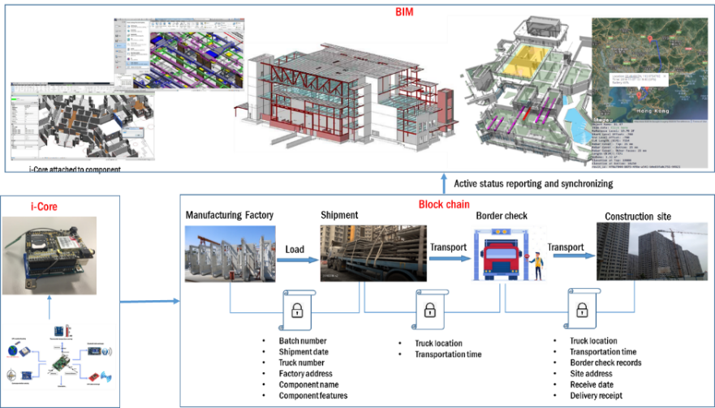

(b) 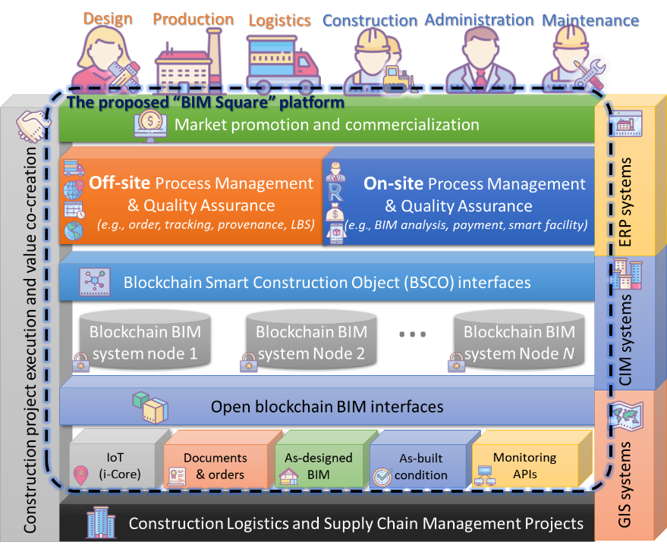

**Figure 2-1**. The BIM² Platform. (a) A conceptual overview, (b) The system architecture

**Table 2-1.** Evidences and external interactions involved in BIM²

|  |  |  |  |  |
| --- | --- | --- | --- | --- |
| ID | XaaS | Evidence process | Media of evidence | External interaction |
| ➊ | IaaS | Reality 🡪 data | Blockchain system | CLSCM practice |
| ➋ | BaaS | Data 🡪 information | Blockchain BIM | Existing ERP systems |
| ➌ | SaaS | Information 🡪 knowledge | PM/QA on end devices | End users |

Table 2-1 summarizes the type, evidence process, media, and external interactions of the three sets. BIM² employs a clear data-information-knowledge (DIK) paradigm to map the evidence from practice to blockchain BIM to users (and existing software systems). The functional components and modules of BIM² platform are shown in Figure 2-1.b. These modules are designated from the overall structure in Figure 2-1.a.

## 2.2 The IaaS core technologies

The first set of deliverables in BIM² is the IaaS core technologies. Figure 2-2 shows the strategic position in the platform. The main aim of the collective core technologies is to extract CLSCM data from everyday practice to blockchain BIM. Two groups of core technologies are designed: (i) hardware and software protocols and (ii) new open blockchain BIM standards.

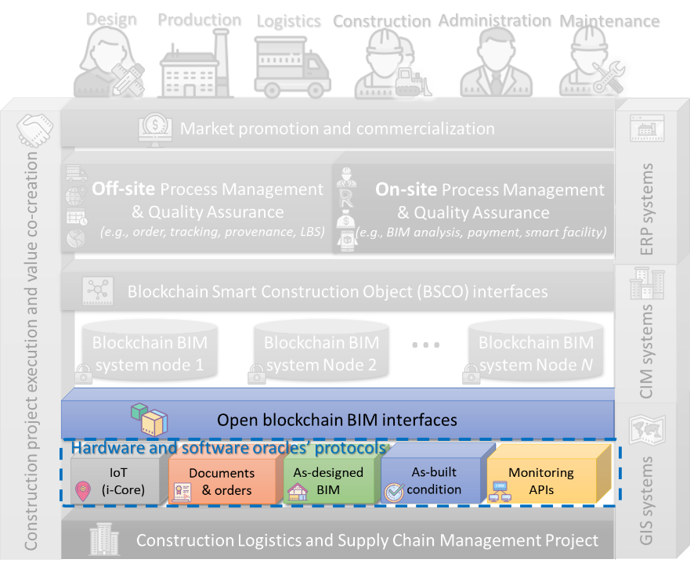

**Figure 2-2.** The position and layers of the IaaS core technologies in the BIM² platform

### 2.2.1 Protocols to hardware and software oracles

Hardware and software oracles are end devices and software to synchronize real-time information between the real CLSCM project and the open BIM standard. The protocols in the BIM² platform are designed to regulate the synchronization of CLSCM reality. The CLSCM process, as shown in Figure 2-3, involves a flow of several steps by several stakeholders. There are existing means to manage the CLSCM activities in practice, such as as-designed BIM, documents, and orders of construction components, construction IoT for CLSCM, and monitoring system of buildings (via the APIs). These existing means and systems cover different phases of the CLSCM process, as shown in Figure 2-3. Therefore, the set of comprehensive hardware and software protocols fulfils the need for mapping and integrating the data in existing means and systems to the BIM² platform.

As far as we are concerned, orders and documents are still the most popular ways to deliver collaboration requests and feedbacks in the real CLSCM industry. The IoT solutions are known to prevail in various supply chains, including CLSCM. Besides, there are some pioneering companies that tried to integrate IoT, as-designed BIM, and wireless sensing network (WSN) monitoring systems into the practice. These protocols thus make the BIM² platform compatible with such existing hardware and software means of data collection. The protocols for interacting with existing CLSCM means and systems apply schematic mapping of multi-dimension (n-D) CLSCM data into the blockchain BIM standard, as shown in Figure 2-3.

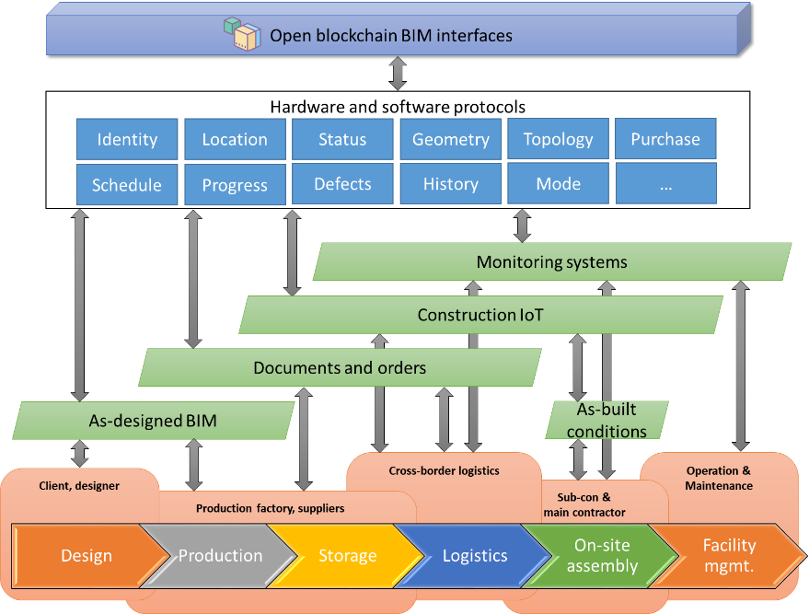

**Figure 2-3.** Protocols to map CLSCM process to blockchain BIM

### 2.2.2 A pilot IoT oracle compatible with the platform

In addition to the general data protocols, a critical hardware “oracle” solution by this project is a smart IoT plan supported by applying our previous i-Core research. In the blockchain technology, such an information exchange agent is called an “oracle.” The *i*-Core technology, developed by the PI, inherits the SCO concept in the CLSCM. As shown in Figure 2-1, our IoT oracle to the blockchain BIM standard integrates possible multiple sensors and blockchain compatibility for the platform, if the CLSCM project does not equip with an existing IoT plan.

The i-Core itself is a flexible board of IoT sensors. For example, inertial measurement unit (IMU) and air pressure units can compensate the GPS locations on accurate motions and height data. Moreover, a supplement of passive RFID and QR codes can stick to the CLSCM object for a lifelong period for facility management. For different purposes of IoT tasks, therefore, a combination of different IoT design profiles can offer the optimal performance-price ratio. Figure 2-4 shows some detailed IoT oracle plans based on the previous i-Core research. The initial plan includes two types of i-Core models:

* **Model 1**: Low-energy, single GPS sensor for LBS offsite PM/QA.
* **Model 2**: High-frequent, multiple motion and environmental sensors for on-site assembly PM/QA.

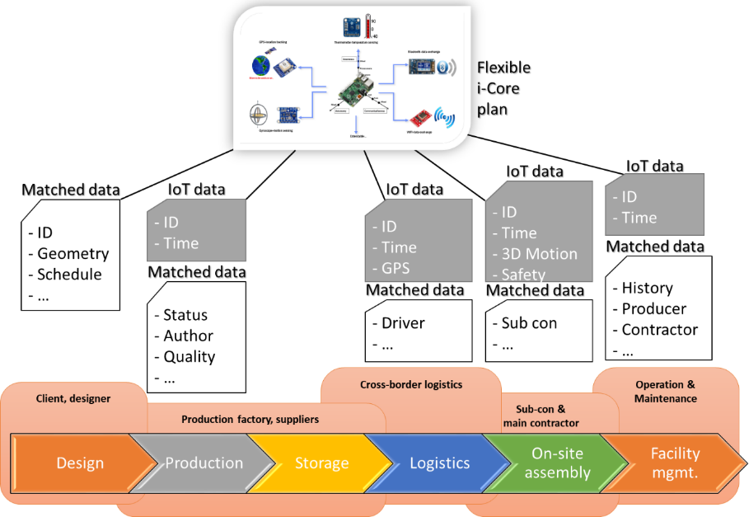

**Figure 2-4.** Diversified IoT oracle plans for CLSCM enabled by i-Core

### 2.2.3 New open blockchain BIM standard

The project team newly develops the BIM standard for the platform. It extends the existing open BIM standard IFC (Industry Foundation Classes, ISO 16739-1:2018). The new standard is an open blockchain BIM standard as a result. As shown in Figure 2-5., the extended BIM standard is capable of handling more functions than the conventional IFC standard. For example, with the schematic definitions in the IFC standard, building analyses can be utilized, such as code checking, structural analysis, cost estimation, facility management, and building service / HVAC (heating, ventilation, and air-conditioning) systems.

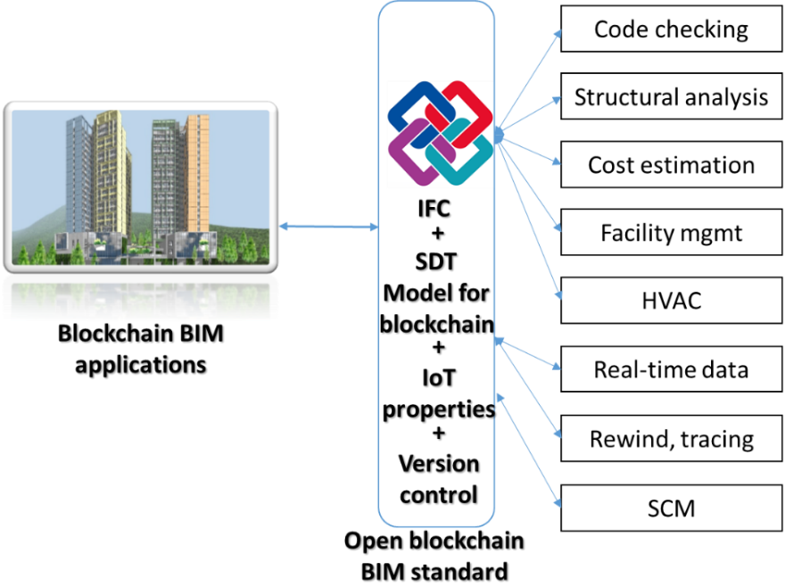

**Figure 2-5**. Extension of IFC standard (ISO 16739-1:2018) to a blockchain open BIM standard

The new extension involves two parts. The first part is a semantic deferential transition (SDT) model for blockchain computability. As stated above, BIMs are usually massive in size and the blockchain is not good at handling massive data due to the network capability. In addition, BIM, as shared by multiple stakeholders, is subjected to simultaneous changes by different parties at the same time. Therefore, it is necessary to define an extension model to bridge the fundamental gap between the IFC and blockchain. Our recent research on SDT, as shown in Figure 2-6, can manage the real-time, simultaneous changes as IFC change consensuses (ICC). The other extension to IFC is the IoT properties, which used to be non-existed in the IFC properties. Examples include production line, logistics company, driver ID, defects, and maintenance history. These new properties are attached to the IFC standard directly.

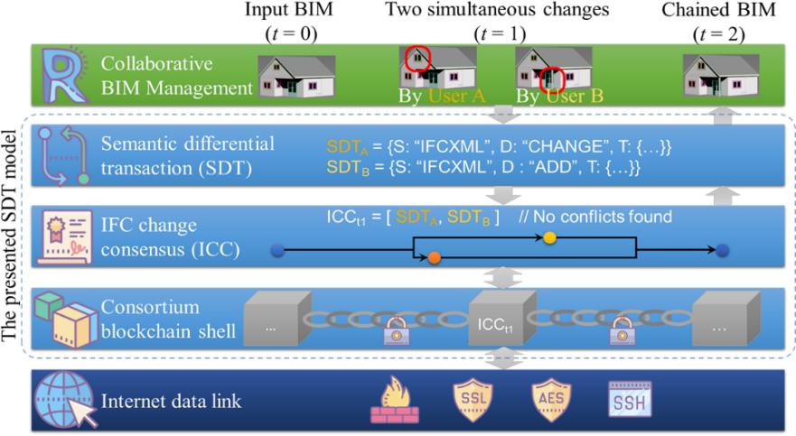

**Figure 2-6**. The semantic differential transaction (SDT) model for blockchaining BIM

## 2.3 The BaaS structure and interfaces

The Blockchain BIM as a Service (BaaS) structure and interfaces are the main infrastructure of functions of the platform. Figure 2-7 shows two primary modules to achieve BaaS functionality. One is the blockchain BIM system. The other is the blockchain smart construction object (BSCO) interfaces, which extends the research team’s previous work on SCO with the new blockchain BIM system. Based on the BSCO, modules like ordering and planning, commercial BIM APIs, and blockchain payment can be developed.

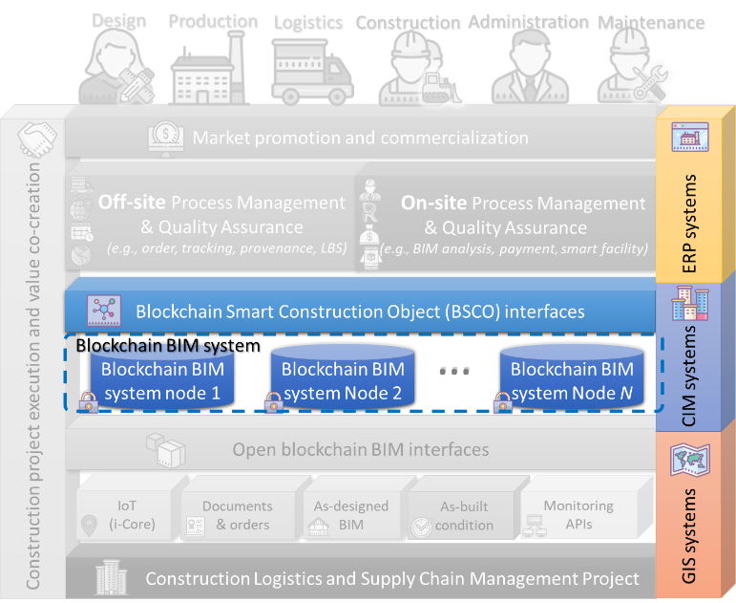

**Figure 2-7.** The BaaS function structure and interfaces in the solution architecture

### 2.3.1 Blockchain BIM system (structure and functions)

The blockchain system offer multi-role stakeholders a distributed, responsive, and trustworthy information infrastructure. However, the stakeholders in a project is not isomorphic peers. For example, the main contractor and administration can have the right to release major submittals from minor BIM versions of submittals. Therefore, the symmetric structures of conventional blockchain structures can be specified for the organizational structure of the construction project. The optimal structure may involve consortium, private, or public.

To explain the idea of a blockchain BIM system, a minimum example in Figure 2-8 describes how massive BIMs are secured on a consortium of blockchain, which is hosted by the multiple stakeholders of a CLSCM project. The system realizes a novel way to CLSCM data management, as well as BIM management. In the blockchain BIM system, each node has a fully working BIM in the local cache, while the SDTs time series is computed in the meantime. The SDTs from all peers form an ICC block after the automatic dispute resolution. A consortium blockchain system manages the BIM in consensus. Each major stakeholder has a designated blockchain BIM node. The signals are from either inbound software oracles, such as commercial BIM APIs and EO’s PMIS systems, or inbound hardware oracles, such as i-Core and as-manufactured building service system IDs.

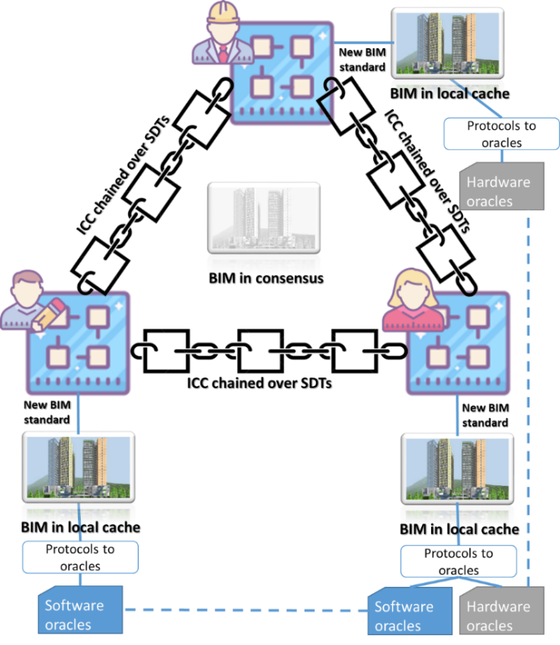

**Figure 2-8.** Example of a consortium blockchain BIM system with ICC over the SDTs

### 2.3.2 Blockchain Smart Construction Objects (BSCO) interfaces for CLSCM

The BSCO interfaces provide accessible calls for other CLSCM function modules. It is extended from the SCO (See Annex 5, Section 2.1). That is, BSCO covers major construction objects such as machinery, tools, device, materials, components, and even temporary or permanent structures. Besides, information reliability for process management and quality assurance is enhanced by introducing the blockchain system. The BSCO derives different interfaces for each stakeholder regarding their intelligence property ownership and contributions to the BIM system of the CLSCM.

First off, administration have the rights to endorse “major version” BIM submittals over the real-time BIM changes. Secondly, though every stakeholder contributes computational power to run and host the blockchain BIM system, the granted accessibility to the information in BIM can be different from one stakeholder to another. For example, the payment information related to a construction element is only available for the manufacturer and the contractor, where the logistics company can have the scheduled transport and installation plans. The details and precision of the information are also diverse, based on the requesting stakeholder. Technically, this can be done in two levels: (i) implementing an access control mechanism over existing blockchain systems; and (ii) designing a tailor-made consensus mechanism for stakeholders.

## 2.4 The SaaS process management and quality assurance applications

The deliverable set of SaaS Management and quality assurance applications bridges the gaps between and the demands of the major CLSCM stakeholders. The major stakeholders involved in a CLSCM project, as shown in Figure 2-9, include the production factory, logistics company, construction sub-contractors, main contractor, administration, maintenance companies, and operation users in two CLSCM scenarios, i.e., LBS off-site PM/QA and on-site assembly PM/QA.

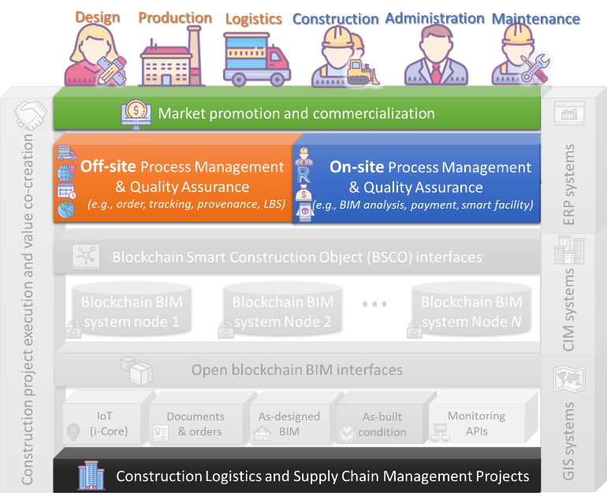

**Figure 2-9.** The Management and quality assurance applications in the solution architecture

### 2.4.1 LBS offsite (production and logistics) process management and quality assurance

CLSCM production and logistics BI are responsible for working out optimal plans and schedules for schedulers/supervisors in prefabrication firms to decide who is to do what with which module. The principal users are module operators and the supervisors, HKU-EO and its collaborative prefabrication producers. It will involve:

* Data Capturing
* CLSCM planning, ordering
* Real-time progress monitoring
* Blockchained construction component tracing and tracking

### 2.4.2 On-site assembly process management and quality assurance

On-site assembly BI is responsible for assisting various operations and supervisions in the prefabrication assembly sites. Examples of the main applications include:

* On-site Assets Management
* Real-time Feedback
* Commercial BIM interoperability
* Blockchain smart payment
* Blockchain-enabled smart facility

# 3 Key Technologies and Innovations

*The innovativeness of the BIM² platform mainly lies in three aspects. The first innovative solution is the blockchain BIM. Another is the i-Core automated blockchain hardware oracles. The third innovative solution is an affordable BIM platform with information and functions.*

## 3.1 Blockchain BIM

The first key technology realizes blockchain BIM. Notably, the technologies include protocols defined for software and hardware protocols and open blockchain BIM standards. This project extends the IFC standard (ISO 16739-1:2018) by appending a set of properties to the BIM family of the precast components. The new blockchain BIM, especially the extra properties, can be better viewed and managed from the cloud, too. The version changes of the BIM over time is computed as the minimum semantic differential transactions (SDTs). The minimum change codes are computed, as shown in the pseudo code in Figure 3-1.

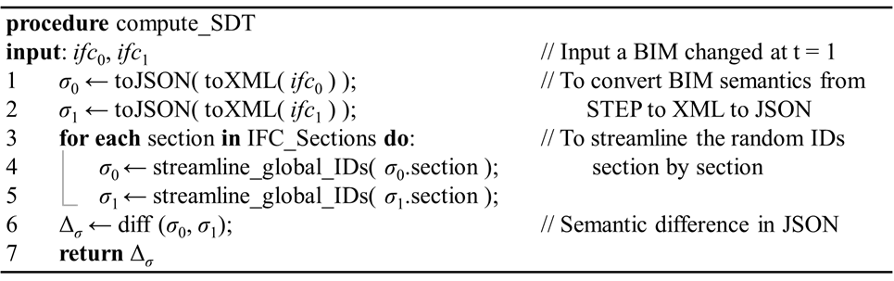

**Figure 3-1.** Pseudo code of SDT computation

Figure 3-2 shows an example illustrating how the new open blockchain BIM standard works on changing an object’s geometry in a BIM. A window on a wall was changed to a larger width in Figure 3-2. The corresponding change record was shown in Figure 3-2.c, where two lines were showing the UID of the window, and the pair of original and changed properties. The changes are associated with the IFC objects by a multi-level decomposition of building hierarchy. The change record is short – which is not available in IFC without SDT – enough for blockchain. Besides, by swapping the value pair of original and changed properties, the time arrow of the changes can be reverted, so that the rewind and tracing operations are available – which are not available in IFC – from the new blockchain BIM standard. With the new blockchain BIM standard, even a massive BIM can be stored on the blockchain. A minimal explanatory case is shown in Figure 3-3. Figure 3-3 is a typical house design, with a disk size at 23M bytes. In contrast to the 23M file size, the ICCs stored in the blockchain is very efficient – between 0.28KB to 1.38KB – in typical scenarios of the logistics.

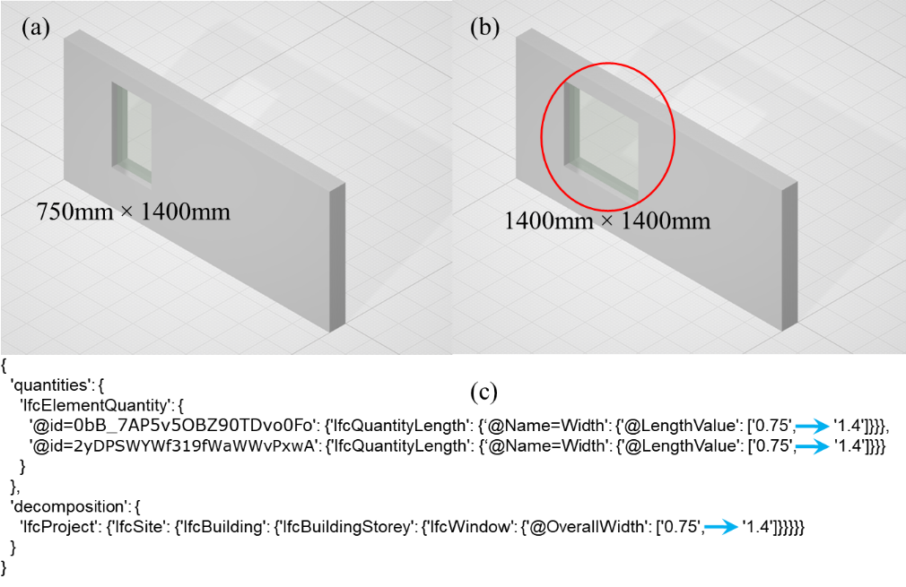

**Figure 3-2.** Illustrative example of the SDT record of a design change. (a) Example wall, (b) window size changed, (c) differential record (0.36KB) of the design change

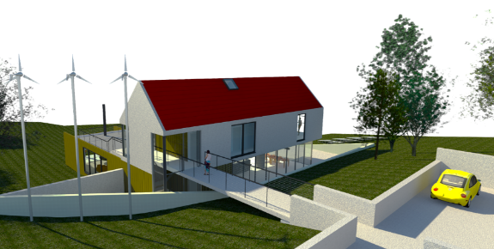

**Figure 3-3.** Example of CLSCM case in a real BIM project (Revit 2018 example project).

## 3.2 *I*-Core as “hardware oracles” for blockchaining

To minimize manual interruption to the CLSCM process, hardware oracles are required by the proposed blockchain BIM system. In this project, distributed oracles are implemented for the distributed blockchain BIM system. That is, the i-Core-enabled construction IoT links the blockchain BIM system to the real-world of CLSCM as a hardware oracle.When combined with such a hardware oracle, blockchain and IoT have the potential to reshape the construction industry and drive it towards effectiveness, accountability, and transparency. BIM² will make use of automated construction IoT, BIM and blockchain for better energy use, resource allocation, and assets management. The automated construction IoT will be implemented for several purposes for smarter construction, such as:

* Real-time BIM,
* Trustworthy order management,
* Supply replenishment, and
* Automated tracking.

The i-Core fulfills the designed functions with sensors and communication. All the required sensors and their related edge computation will be integrated in i-Core. The sensor data can be further leveraged by the IaaS/BaaS APIs to other systems. It is of more lucidity by integrating the IoT technologies in one solution – i-Core:

* **Type (1)**: Low-power version for geolocation-based services (LBS) QA during manufacturing and logistics. The primary sensor is GPS/A-GPS (e.g., Beidou). This type of i-Core aims at long battery life, less unit cost, and higher durability for off-site users, at a cost of less-frequent reporting (e.g., every 10 mins).
* **Type (2):** Sensor-fusion version for digital twinning components’ real-time motions and QA functions on site. A selection of sensors such as motion, compass, altimeter, environmental, etc., will be included in the second type. The downside is the high power consumption (e.g., to recharge every day).

## 3.3 Open, affordable BIM platform and functions

**Open, IFC-compatible BIM platform:** The proposed BIM² platform is built on an open BIM standard extended from IFC. Therefore, the BIM in consensus and BIM in the local cache are IFC compatible. The open BIM platform enables innovative use cases, e.g., in Figure 3-4. For instance, the BIM² platform and the open BIM standard can help the public body (e.g., government agency reluctant to mandating commercial software) access and assess the BIMs developed on commercial platforms. New information and functions are also easy to implement on an open BIM platform. The decision support functions will be implemented in the SaaS PM/QA applications for facilitating the physically distributed stakeholders:

* CLSCM planning, ordering
* Real-time progress monitoring
* Blockchained construction component tracing and tracking
* On-site Assets Management
* Real-time Feedback
* Commercial BIM interoperability
* Blockchain smart payment
* Blockchain-enabled smart facility.

The BIM² platform might start to encourage and nurture an open BIM eco-system in the local construction industry.

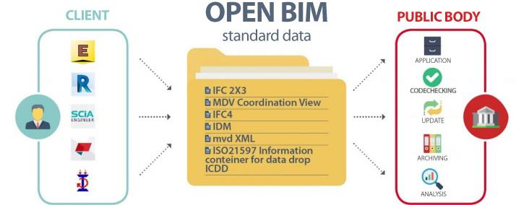

**Figure 3-4.** IFC-compatible open BIM use. (a) Bridging commercial BIM platforms to public body’s function; (b) Interoperating information in an open, extensible manner

**Affordable BIM software**: Commercial BIM platforms are every expensive. Unlike the fixed-price home licenses, for example of Microsoft Windows and Office, many BIM platforms’ subscription fees are tens to hundreds of thousands of dollars per computer per year. The cost will be scaling up to multi-million dollars per year for a single construction project. Such a high level of cost is unaffordable for small and medium-sized enterprises (SMEs), which count for over 90% of construction companies in Hong Kong. The BIM² platform will offer free BIM functions if subscribing to the blockchain.

**Compatibility with existing commercial BIM software**: To explore the potential market, the combustibility list of the BIM² platform will include one or two mainstream commercial BIM software. For example, a plugin can mirror the major functions, e.g., CLSCM planning, ordering, and blockchained construction component tracing and tracking, to users in Autodesk Revit. Such a plugin will enhance the user-friendliness for many BIM users.

# 4 Implementation Plan

## 4.1 Methodology and strategies

The development of the BIM² platform will follow a mixed methodology of software development. In general, the whole project will go from one milestone to another, ensuring that each is built on a solid foundation. For each deliverable, the analysis, detailed design, implementation, debugging, tests, deployment, and documentation will mainly follow the Agile methodology, as shown in Figure 4-1. Agile is an iterative, team-based approach to software development, under which requirements and solutions evolve through the collaborative effort of self-organizing cross-functional teams (Collier 2012). The concepts of Agile meet the requirements of the processes in each software deliverable of the BIM² platform very well.

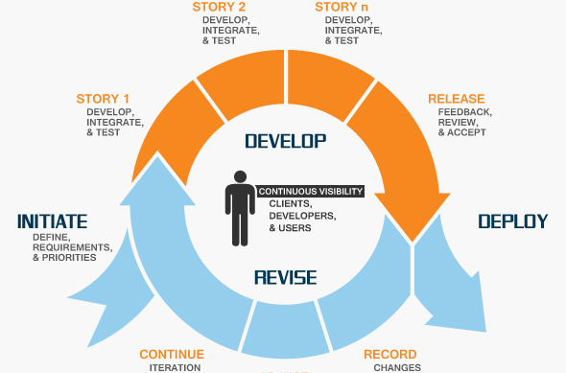

**Figure 4-1**. Process flow of the Agile software development

With the Agile methodology, the project team and our industry collaborator can be engaged at an early stage. The end-users can also be involved as early as possible. Also, it has been reported that Agile has good results in predictable costs and reliable scheduling as well as flexibility for possible changes.

## 4.2 Implementation plans in project milestones

The project team consists of four PC/Co-PIs and three Co-Is. The proposed deliverables will be a cooperative work of seven sets as follows.

(1) System architecture developed through a thorough BPR analysis

(2) The IaaS core technologies and protocols

(3) The BaaS structure and interfaces

(4) The multi-stakeholder SaaS Management and quality assurance applications

(5) Technology integrity, KPI benchmarking, and scalability test results

(6) A project website for project promotion and dissemination

(7) Dissemination and promotion training workshops/seminars/exhibitions

The deliverables (2)-(4) are scheduled in mixed principles of Agile and conventional module-by-module software development. The three software deliverables will be initialized one by one, but they will be integrated, debugged, and tested altogether. Each software deliverable will have four versions (stages): Alpha version (working, with major features), Beta version (working reliably, almost all features achieved), Release candidate (optimized, reliable, probably with small bugs), and 1.0 version (for final release).

The overall project plan is shown in Figure 4-2.

|  |  |  |  |  |  |
| --- | --- | --- | --- | --- | --- |
| **Deliverable** | **Milestone 1**  **(6 months)** | **Milestone 2 (6 months)** | **Milestone 3 (6 months)** | **Milestone 4 (6 months)** | **Led by** |
| **(1) Requirement & BIM² architecture** | V 1.0 ✓ |  |  |  | PC, Co-PIs |
| **(2) BIM² – IaaS** | Alpha | Beta | RC | V 1.0 ✓ | PC |
| **(3) BIM² – BaaS** |  | Alpha | Beta | V 1.0 ✓ | SMY |
| **(4) BIM² – SaaS** |  | Alpha | Beta | V 1.0 ✓ | AGOY, FX |
| **(5) Integration & tests** |  |  |  | V 1.0 ✓ | PC |
| **(6) Project website** | V 1.0 ✓ |  |  |  | PC |
| **(7) Promotion & Dissemination** |  | ✓ |  | ✓ | PC, GHH, KLT |
| **Regular Project Advisory Meetings** | Meeting 1 | Meeting 2 | Meeting 3 | Completion | PAC |

**Figure 4-2**. Gantt chart of the scheduled project plan for the deliverables

## 4.3 Technology integration and scalability test

The BIM² platform aims to integrate open BIM standard IFC, with various software and hardware oracles (e.g., as-designed BIM and construction IoT) into a novel open blockchain BIM platform. Data and information will not only synchronized but also permanently pinpointed on-chain. The integration will be carried out through several aspects.

First, the existing construction software and hardware systems are mapped to an open BIM standard, through proposed “oracle” protocols. The mapping process also involves tests on knowledge-guided data cleansing and fusion. Secondly, the CLSCM data is stored on blockchain BIM, which is a BIM system as well as a blockchain system. A set of scalability tests will be conducted to confirm the capacity and capability of the blockchain BIM system. The BIM objects are re-defined as BSCO to access the blockchain BIM system. Uniform BSCO interfaces are defined for higher business logic functions. A performance benchmark test is arranged for BSCO interfaces.

The CLSCM function structure and interfaces bridge the stakeholders’ demands and the BSCO interfaces. Three typical CLSCM scenarios are developed throughout the construction lifecycle: production and logistics, on-site assembly, and facility management. The three developments will be integrated into the vision of the project team. After the integration, the BIM² platform will be tested on the scalability and performance in several cases with all operations and information flow related to current construction conventions in Hong Kong. The test will invite a wide range of involved companies, parties, and technology providers in real-life cases so that comments and improvements suggestions could be obtained from frontline companies and workers.

## 4.4 Expected key performance indicators of the platform

Six categories of Key Performance Indicators (KPIs) are listed in Table 4-1. In contrast with the existing commercial competitors that are cloud BIM platforms, the proposed BIM² platform is competitive. First of all, the proposed BIM² platform is expected to be unmatchable by its rivals in the first category, “Information reliability,” due to the immutability of the blockchain. The BIM² platform, with an in-depth integration to daily operations, is expected to reduce 40% inquiry emails and phone calls regarding ordering issues, and 15% communications on quality and compliance issues between the stakeholders. With the up-to-date information of MiC components, we expect to save 30% of locationing time on sites and at a factory and 5% leading time by compressing untraceable products and delivery risks.

The performance of BIM² will be measured by the last three groups of KPIs in Table 4-1. First, the capacity of BIM model size will be guaranteed at 1.0GB. However, the project team will try to ensure the maximum capacity up to 8.0GB. The BIM² is expected to outperform the commercial cloud BIM platforms on the IFC open standard and other open BIM files. For example, we estimate to have a 100% compatibility with the IFC while the best commercial BIM platforms have known information loss. Meanwhile, the BIM² will catch up with the commercial BIM formats via plugins and APIs. Lastly, the BIM² may experience a bit larger latency on the web end and blockchain nodes than commercial rivals. The main reason lies in the network hardware investment at the R & D stage; we anticipate a smart contract acceleration network can fix this potential problem in the commercialization stage.

**Table 4-1**. Comparison of KPIs between the proposed platform and known commercial competitor of cloud BIM

|  |  |  |  |
| --- | --- | --- | --- |
| Category | Performance Indicator | Expected value | Competitor (commercial cloud BIM) |
| 1 Information reliability | Components’ information reliability | 100% | – a |
| 2 Project communications | Ordering related emails enquiries and phone calls | –40% | – a |
| Quality and compliance related emails and phone calls | –15% | – a |
| 3 CLSCM performance | Component locationing time | –30% | – a |
| Leading time | –5% | – a |
| 4 Blockchain BIM capacity | Maximum BIM model size | **1.0 GB** | N.A. b |
| 5 System compatibility | IFC standard | **100%** | ~95%c |
| Commercial BIM platforms | 85% | **~95%** |
| Other open BIM platforms | **95%** | ~90%c |
| 6 System response time | Web-based BIM monitoring | < 5 seconds | **< 2 seconds** |
| BIM change contract confirmation duration | < 5 seconds | **< 2 seconds (cloud)** |
| Blockchain SCO query | < 3 seconds | **< 1 seconds (cloud)** |

(a: depending on R&D; b: Not available now; c: due to information loss in format conversion)

To sum up, the proposed BIM² has a unique competitive edge against existing commercial BIM platforms available on the market. And the project team will gauge the performance and competitiveness using the KPIs.

## 4.5 Blockchain nodes formation and development

We proposed to use a permissioned federation architecture, e.g., project consortium. The number *N* of nodes involved in the BIM² will be provided by the stakeholders (simulated by the working groups in the R&D) based on a Proof-of-Stake (PoS) like system such as Proof-of-Cyber-Pysical-Stake (PoCPS).

In addition, project channels and task channels will be designed within the permissioned architecture to protect privacy on demand. A considerable part of information in BIM is classified as business secret. So it is not an option to store BIM data outside of the project stakeholders. Even as a stakeholder, end users can access a designated BSCOs (part of data) based on their roles; while the full BIM information is encrypted in the lower-level blockchain backbone.

As a result of the permissioned architecture and channels, a typical construction project’s 5~50 stakeholders can afford its nodes and computation. In the R&D, we will have various stakeholders involved in a project, such as client (HKU), consultants (various professionals), main contractor, and many suppliers. Regarding the physical separations and heterogeneous node fundamentals, invading such a federation blockchain is almost impossible due to the robust PoS/PoCPS consensus system.

# References

Collier, K. (2012). *Agile analytics: A value-driven approach to business intelligence and data warehousing.* Addison-Wesley.